**LAB 6**

**6.1 Program that prints first 20 integers in reverse order**

**SOURCE CODE**

#include <iostream>

using namespace std;

int main ()

{

for (int x=20; x>=0; x--)

{

cout<<x<<endl;

}

return 0;

}

**OUTPUT**

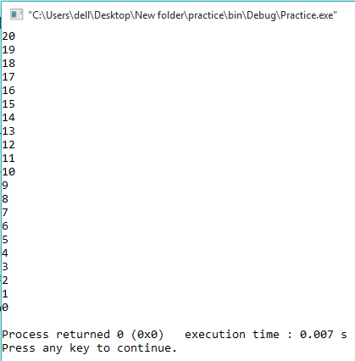

**6.2 Write a program to generate a Fibonacci Series of given numbers of n terms.**

**SOURCE CODE**

#include <iostream>

using namespace std;

int main() {

int n1=0,n2=1,n3,i,number;

cout<<"Enter the number of elements: ";

cin>>number;

cout<<n1<<" "<<n2<<" ";

for(i=2;i<number;++i)

{

n3=n1+n2;

cout<<n3<<" ";

n1=n2;

n2=n3;

}

return 0;

}

**OUTPUT**

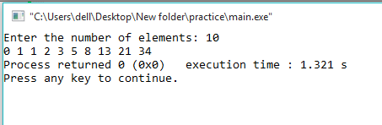

**6.3 Write a program in C++ to check whether a number is prime or not**

**SOURCE CODE**

#include <iostream>

using namespace std;

int main ()

{

int a,b=0,c=0,d=0;

cin>>a;

c=a;

do

{

a--;

b=a;

for(int i=2; i<=a; i++)

{

d=i*b;

if(d==c)

{

cout<<"Number is not prime"<<endl;

return 0;

}

}

}

while(a>=0);

if(d!=c)

{

cout<<"Number is prime"<<endl;

}

return 0;

}

**OUTPUT**

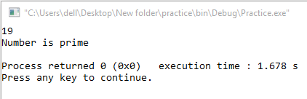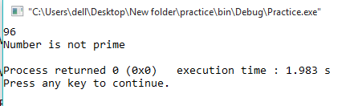

**6.4 Write a Program to generate an Armstrong number**

**SOURCE CODE**

#include <iostream>

using namespace std;

int main() {

int num, sum = 0, digit;

cout<<"Enter a positive integer: ";

cin>>num;

for(int I=num; I!=0;){

digit = I % 10;

sum = sum +(digit * digit * digit);

I = I/10;

}

if(sum == num)

cout<<num<<" is an Armstrong number.";

else

cout<<num<<" is not an Armstrong number.";

return 0;

}

**OUTPUT**

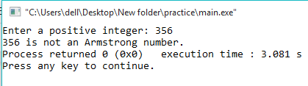

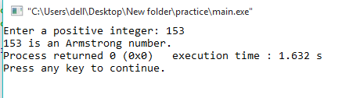

**6.4 Write a Program to generate an Armstrong number**

**SOURCE CODE**

#include <cmath>

#include <iostream>

using namespace std;

int main(){

int sum, num;

cout<<"Armstrong numbers between 1 and 1000: ";

for(int i = 0; i < 10; i++) {

for(int j = 0; j < 10; j++) {

for(int k = 0; k < 10; k++) {

num = i * 100 + j * 10 + k;

sum = pow(i, 3) + pow(j, 3) + pow(k, 3);

if(num == sum)

cout<<num<<" ";

}

}

}

return 0;

}

**OUTPUT**

